|  |
| --- |
| Encryption & Decryption of Text File using LabVIEW |
| Engineering Analysis and Design (ECN 206) |

|  |
| --- |
| Submitted by :  Name : Gagandeep Chauhan  SID : 18105023 |

**INTRODUCTION :**

Provision of adequate security to confidential data or classified information is always a major concern in the fields of defence, government offices, banking and even for civilians. Hence protection of information from unauthorized access is crucial. Thus we go for data encryption. Encryption is the process of converting a data or a plain-text into an incomprehensible form known as cipher-text. Encryption can be used for data at rest, i.e. files on computers, USB drives, etc as well as for data in transit, such as data that is being transmitted over the internet like e-commerce, communication systems. Decryption is the reverse process of encryption. It is the process of converting the cipher-text back into intelligible form of data. This can be realized using various algorithms.

**Software Used :**

LabVIEW 2019

**WORKING :**

Using the designed system, the text file that needs to be transformed is received as input. The characters of the data file is extracted and converted into ASCII codes. This is then subjected to FFT algorithm to obtain an encrypted file and is ready to be transmitted. The encrypted text file is received as input at decryptor module and decrypted using IFFT algorithm. The whole system is implemented in LabVIEW.

Encryption of Text File :

The text file that has to be encrypted is given as input and data is extracted from it and converted to ASCII codes. The ASCII codes are then subjected to FFT algorithm for further encryption.

The floating output from FFT algorithm is converted to a string and written to the text file in an encrypted form.

Block Diagram :

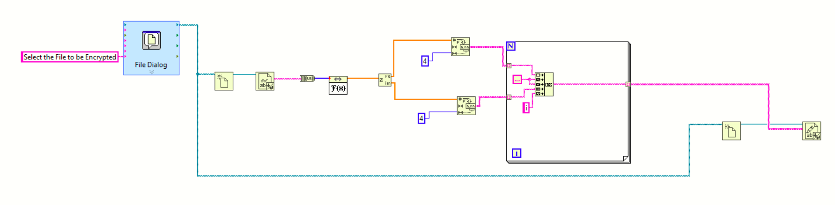

Decryption of Text File :

The file to be decrypted is given as input. VI asks for a password from the user to provide only authorised access to the document. If the password entered by the user is correct, data is extracted from the file and subjected to IFFT algorithm. The output from the IFFT is converted to a string and written to the text file. The text file that we get as output has the same data as the original text file.

If the password entered by the user is incorrect, no decryption is done.

Block Diagram :

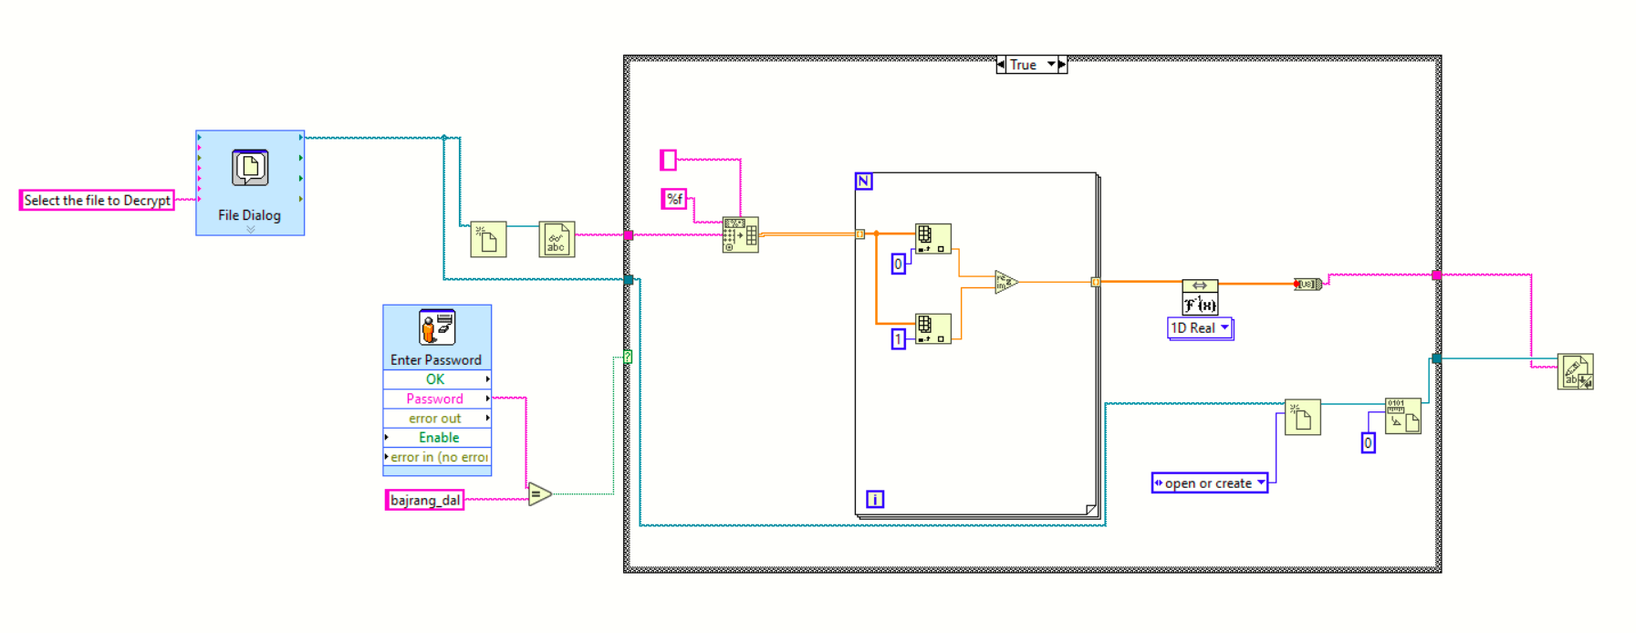

**CONCLUSION :**

The application designed provides high security to our data in the text form. It can be used to encrypt text files containing vital information such as bank details and security information before sharing them over public networks like internet and public Wi-Fis. It provides security and prevents leakage of vital information to unauthorised people.